Authors: Emilia Perez, Ahtziri Aguirre, Fernando Casillas, Resselly Rincon
Instructor: Jongwook Woo
Date: 04/28/2026

Lab Tutorial
Emilia Perez (jperez451@calstatela.edu)
04/28/2026

Creating a Bar Chart Using Kibana

Objectives
In this hands-on lab, you will learn how to:
- Obtain datasets using Kaggle
- Turn an excel file into an index/data view using Kibana
- Aggregate data using Kibana
- Create charts using Kibana

Platform Specs
- Acer Aspire A315-24PT
- CPU Speed: 2.8 GHz
- # of CPU cores: 8
- # of Nodes: 1
- Total Memory Size: 16 GB

Step 1: Obtain the Dataset using Kaggle
This step is to obtain the dataset needed to begin the process of turning it into a chart.
- Open your browser and in the search bar, enter https://www.kaggle.com/
- Click on ‘Register’ in the top right corner, and then click on ‘Register with Google’ or ‘Register with Email’ based on your preference



- Finish the sign-up process and then go to https://www.kaggle.com/datasets/iamsouravbanerjee/airline-dataset
- Click on Download in the top right corner, then click on ‘Download dataset as zip’
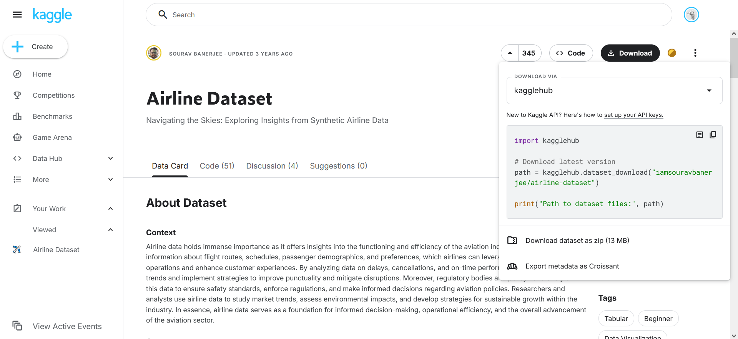

- Open your File Manager, then go to your downloads page

- Right click on the archive.zip folder, then click ‘Extract all’ and ‘Extract’ on the next window pop-up
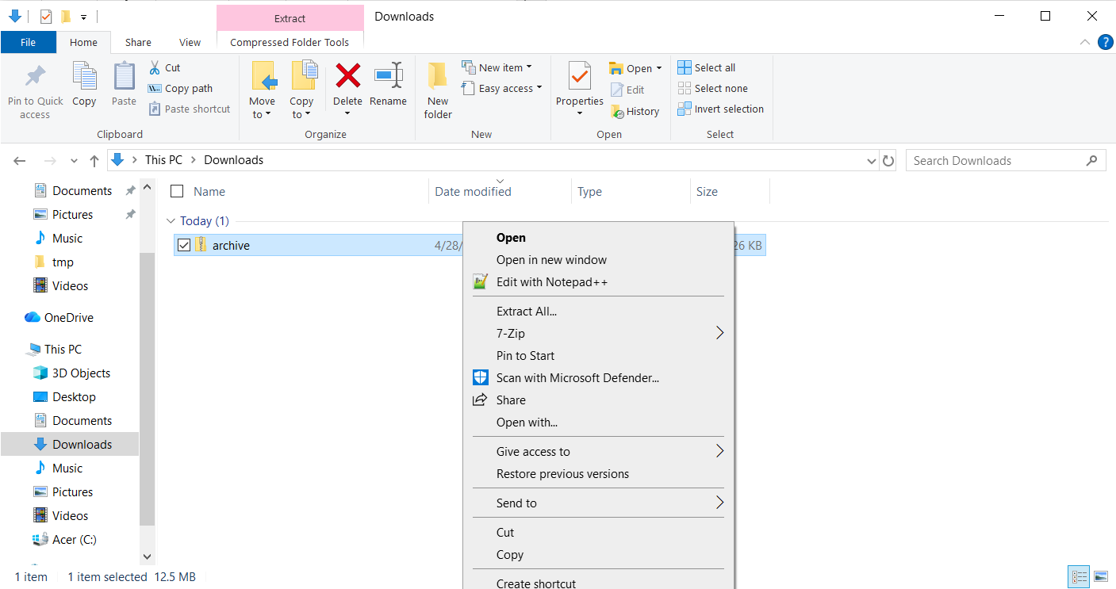
- You will now have a folder with 3 data sets, the one we will use is ‘Airline Dataset Updated – v2’

Step 2: Upload the Dataset to Kibana
This next step is to upload the excel dataset to Kibana to easily create new charts
- Log into Elastic with your credentials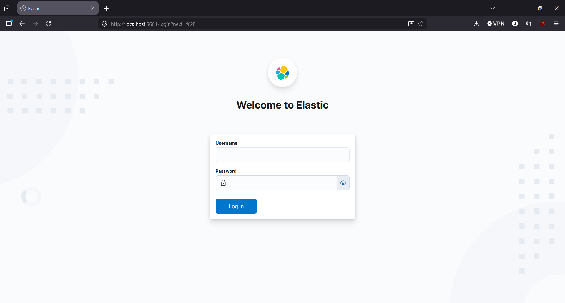
- Open the sidebar on the left-hand side of the screen and click on ‘Machine Learning’ underneath the ‘Analytics’ Section
- Click on Data Visualizer and you will be asked to select a file
- Open the unzipped ‘archive’ folder and select ‘Airline Dataset Updated – v2’
- If all the steps were done correctly, you should see the following:
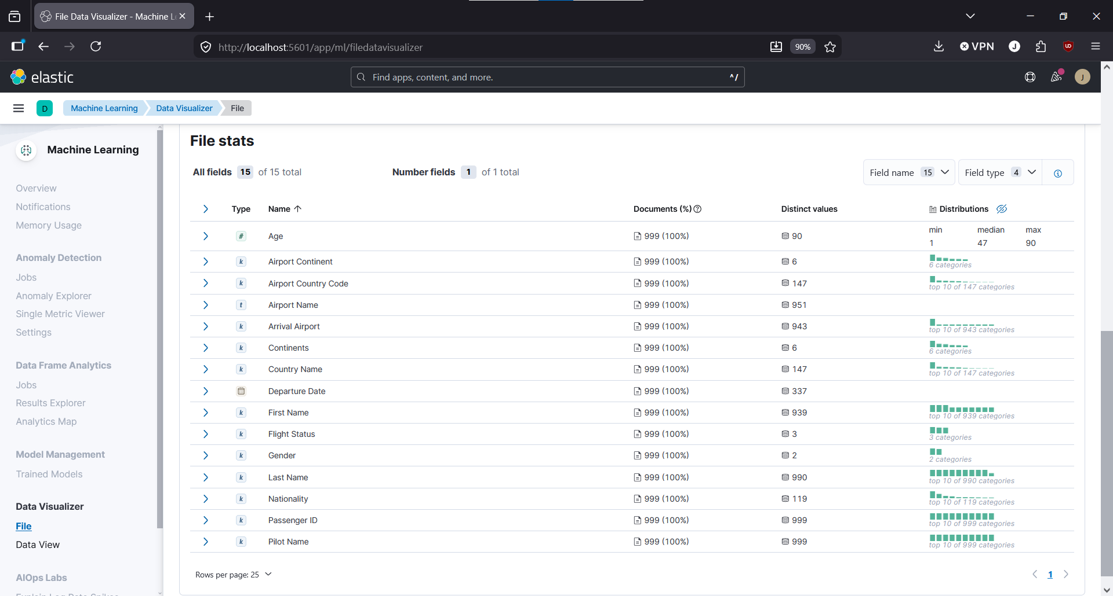
- Click on import and for the index name, type ‘airline-dataset’ and make sure that the ‘Create data view’ box is checked
- Once complete, click on ‘View Index in Discover’ to verify that it was done successfully

Step 3: Visualizing the Dataset with Kibana
- Still on Kibana, open the sidebar on the left-hand side of the screen and click on ‘Visualize Library’ underneath the ‘Analytics’ Section
- Click on ‘Create new visualization’ then click on ‘Aggregation Based’ and finally click on ‘Vertical Bar’
- Under the Y-Axis, make sure that ‘Aggregation’ is set to ‘Count’ and input ‘Number of Flights Cancelled or Delayed’
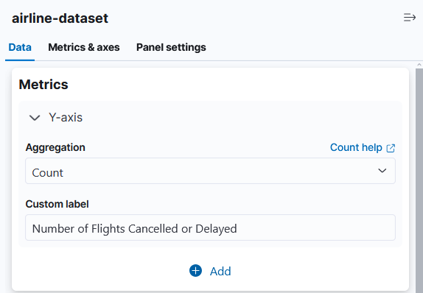
- Under Buckets, click on ‘+ Add’ and select ‘X-Axis’
- Set Aggregation to ‘Terms’ and the ‘Field’ to ‘Country Name.’ Leave Order alone and set size to 10. For the custom label, name it ‘Country Names, Descending’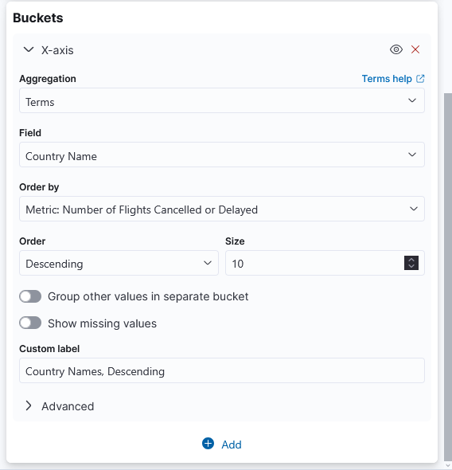

- In the top right corner, set the start time to be ‘Jan 1, 2022 @ 00:00:00.000’ and end time to be ‘Dec 31, 2022 @ 23:30:00.000’ Make sure that these values are set to Absolute.
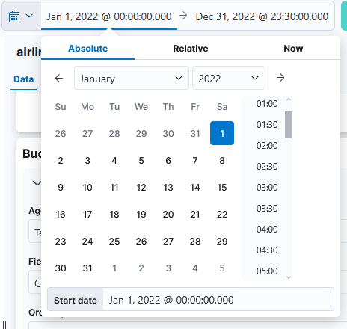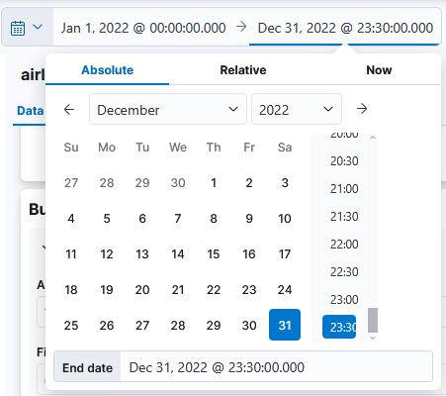
- On the top of the page, there will be a search bar that says ‘Filter your data using KQL syntax’
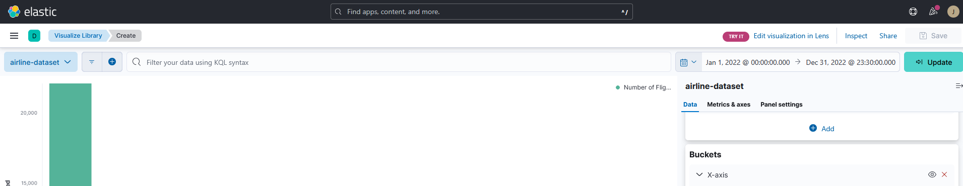
- Enter into the KQL Query, ‘ Flight Status :"Cancelled" or Flight Status :"Delayed" ‘and click Update on the top right corner.
- Your chart should now show the top 10 countries with cancelled or delayed flights in the year of 2022
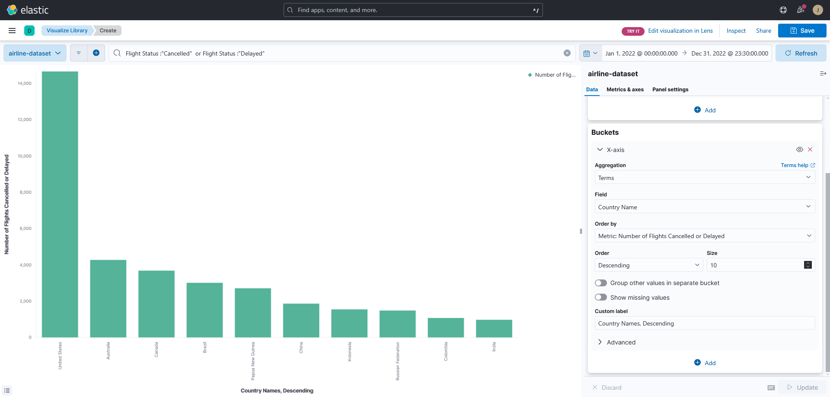
References
- Data Source: https://www.kaggle.com/datasets/iamsouravbanerjee/airline-dataset
- GitHub: https://github.com/StrayBerry512/CIS-3200-Final

